**A1) Purpose of the Website (2 mark)**

The purpose of my portfolio website is to provide a platform for my viewers and clients to view my photography work. It also promotes and advertises my business to a boarder clientele, allowing me to gain more freelance work and hopefully in turn increase my clientele. Thus expanding my business. The website also allows me to build up my social media platforms, through the use of hyperlinks, for others to see.

**A3) Analysis of Copyright issues (5 marks)**

Copyright is an intangible property that is the result of creativity or plagiarism. It is a type of intellectual property (IP) which is represented by the © symbol. When designing a website, music, books, blogs, podcasts, paintings and even software, you must be careful that you are not copyrighting someone’s work because you can be prosecuted with copyright infringement. You will face major consequences of jail time as well as large fines. There are many ways to work around the problem of copyright, one of them being the Creative Commons license.

The Creative Commons license (CC licence) provides individual creators as well as companies and institutions a way to share their work without infringing copyright. When classifying your work under a CC licence, it means that you are allowing others to use your content in various ways under your conditions. The conditions are set under the six types of standardised CC licences:

1. Attribution CC BY,
2. Attribution sharealike CC BY-SA,
3. Attribution-noderivs CC BY-ND,
4. Attribution-noncommercial CC BY-NC,
5. Attribution-noncommercial-sharealike CC BY-NC-SA and
6. Attribution-noncommercial-noderivs CC BY-NC-ND.

The different CC licenses allow bassline permissions to users, authorising them the use of the creator’s materials provided they comply with the core conditions. The core conditions applies to all six of the licenses and declares that the author’s work is credited. As well as the user of the content must not use the content for commercial use, Non-Commercial (NC), or copy the work without changing anything, No Derivatives (ND), As well as they must share their work under the same the licence terms that govern the original work, Share Alike (SA).

The Creative Commons license (CC License) allows creators such as web designers and music producers to produce content that stems from others work, if they follow the core conditions that are set under the six types of standardised CC licences of, Non-Commercial (NC), No Derivatives (ND), and Share Alike (SA).

**A4) References (3 marks)**

#### Creative Commons. (2019). *Licenses and Examples - Creative Commons*. [online] Available at: https://creativecommons.org/share-your-work/licensing-types-examples/licensing-examples/ [Accessed 1 Apr. 2019].

* legalzoom.com. (2015). *How to Avoid Copyright Infringement*. [online] Available at: https://www.legalzoom.com/articles/how-to-avoid-copyright-infringement [Accessed 1 Apr. 2019].

#### Creative Commons Australia. (2010). *About the Licences*. [online] Available at: https://creativecommons.org.au/learn/licences/ [Accessed 1 Apr. 2019].

#### Paragon Digital Marketing. (2014). *How to Avoid Copyright Infringement on the Web*. [online] Available at: https://paragondigital.com/blog/how-to-avoid-copyright-infringement/ [Accessed 1 Apr. 2019].

* 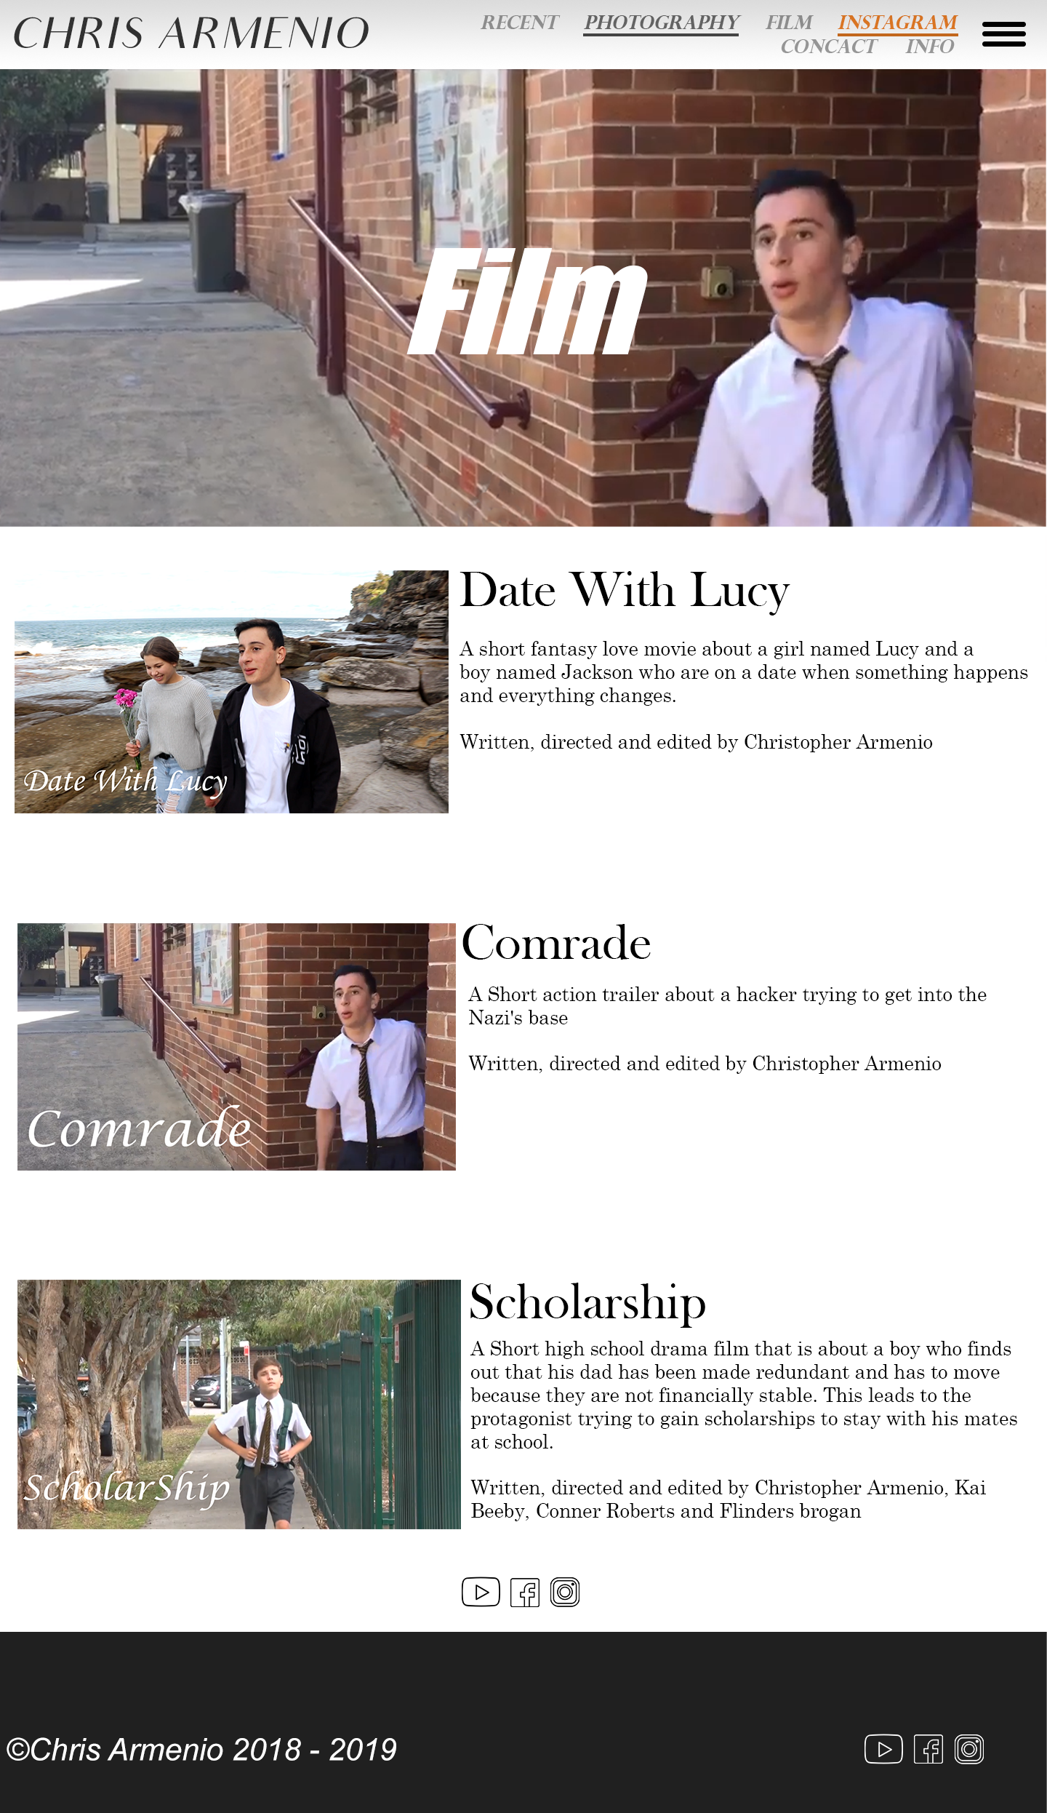**A2) Storyboard (5 marks)**

Each hyperlinks to a different page

My name, (Chris Armenio), hyperlinks to the top of the page.

Embed YouTube videos from JavaScript/Google API

Embed YouTube videos from JavaScript/Google API

Links to Social Medias, Youtube, Facebook, and Instagram.

Declaration of copyright.

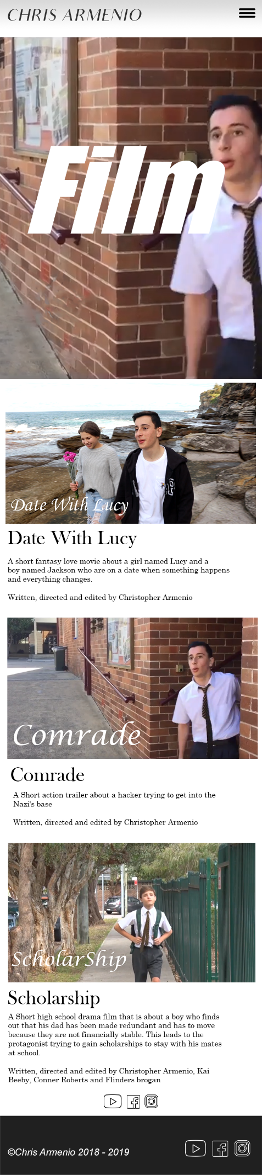

Toggle button, each hyperlink to a different

page which opens all the page tabs.

My name, (Chris Armenio), hyperlinks to the top of the page.

Embed YouTube videos from JavaScript/Google API

Embed YouTube videos from JavaScript/Google API

Hyperlinks to Social Medias, Youtube, Facebook, and Instagram

Declaration of copyright

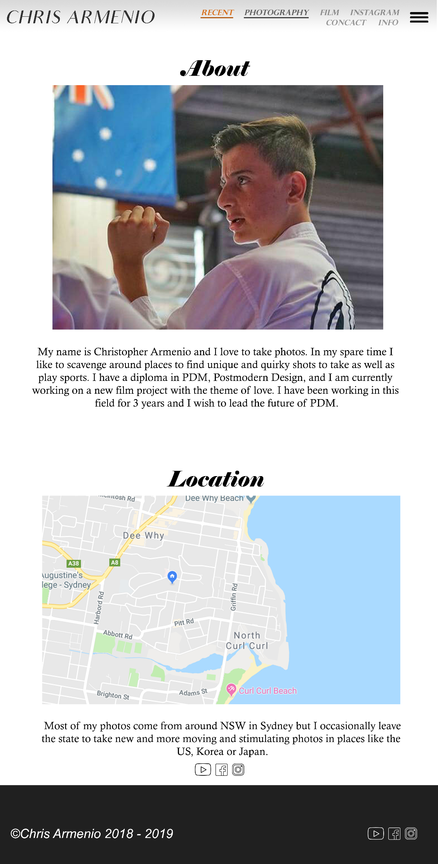

Each hyperlinks to a different page.

My name, (Chris Armenio), hyperlinks to the top of the page.

Photo of Me.

Description of myself.

Embed map of Sydney.

Description of where I live.

Hyperlinks to Social Medias, Youtube, Facebook, and Instagram.

Declaration of copyright

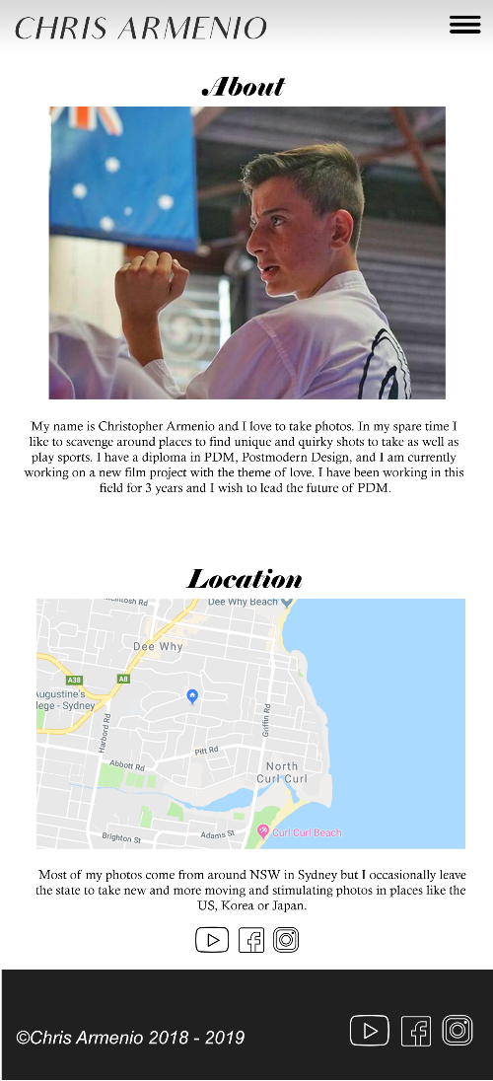

Toggle button, each hyperlink to a different

page which opens all the page tabs

My name, (Chris Armenio), hyperlinks to the top of the page.

Hyperlinks to Social Medias, Youtube, Facebook, and Instagram

Declaration of copyright

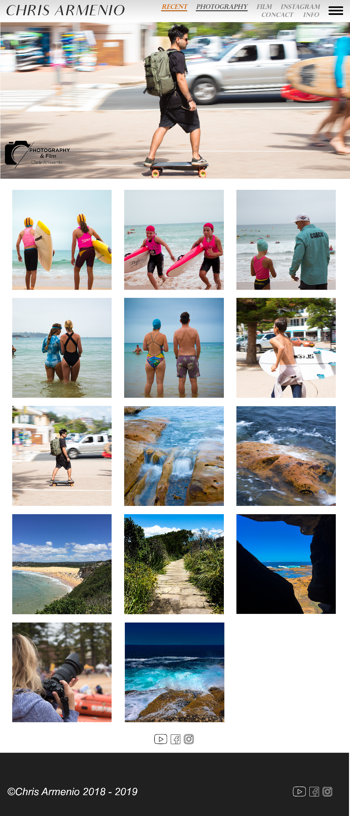

Each links to a different page

My name, (Chris Armenio), hyperlinks to the top of the page.

Images uploaded by JavaScript

Hyperlinks to Social Medias, Youtube, Facebook, and Instagram

Declaration of copyright

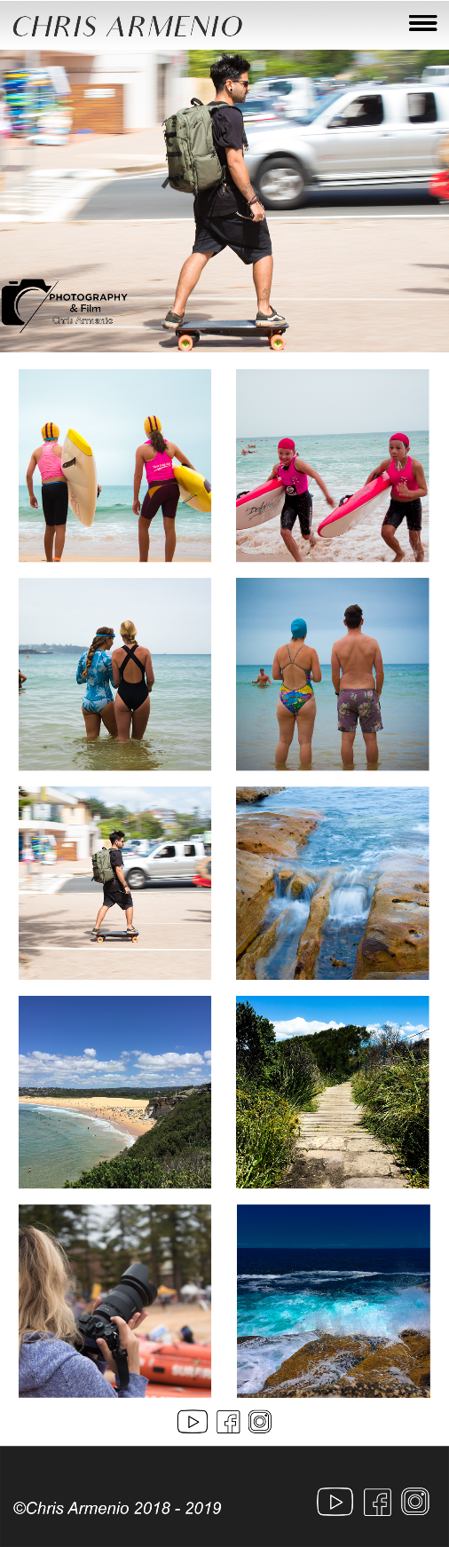

Toggle button, each hyperlink to a different

page which opens all the page tabs

My name, (Chris Armenio), hyperlinks to the top of the page.

Images uploaded by JavaScript

Hyperlinks to Social Medias, Youtube, Facebook, and Instagram

Declaration of copyright

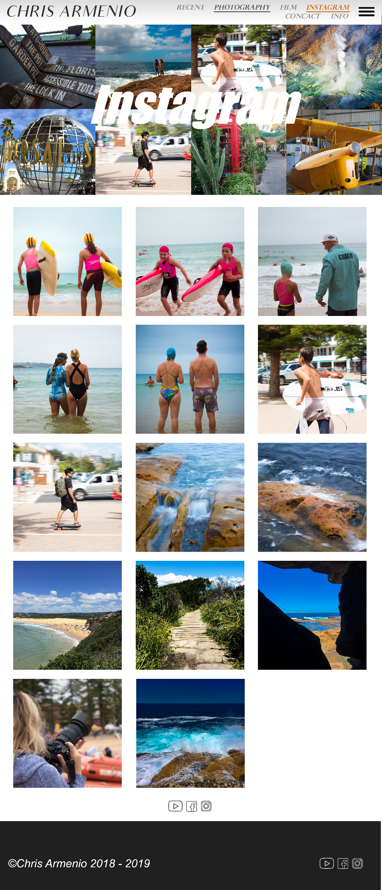

Each links to a different page

My name, (Chris Armenio), hyperlinks to the top of the page.

Images from Instagram

Uploaded by Instagram API

Hyperlinks to Social Medias, Youtube, Facebook, and Instagram

Declaration of copyright

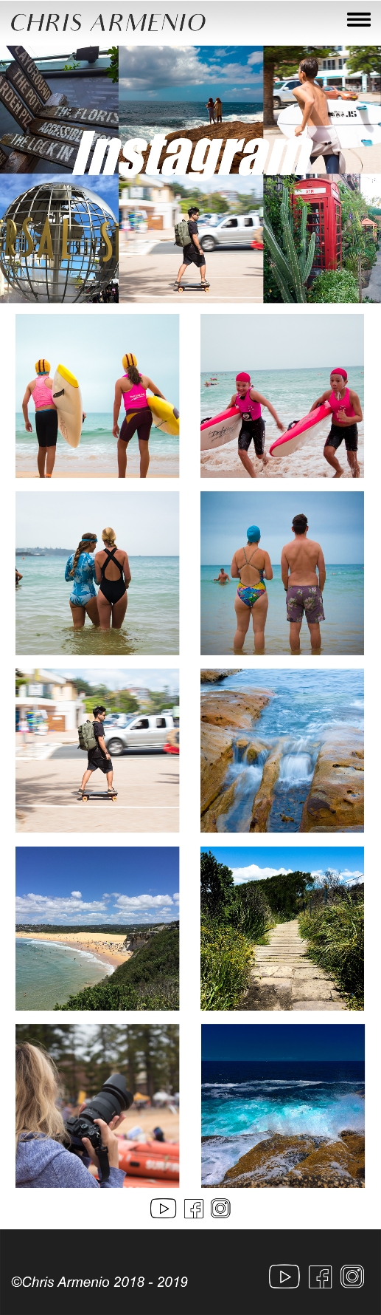Toggle button, each hyperlink to a different

page which opens all the page tabs

My name, (Chris Armenio), hyperlinks to the top of the page.

Images from Instagram

uploaded by Instagram API

Hyperlinks to Social Medias, Youtube, Facebook, and Instagram

Declaration of copyright

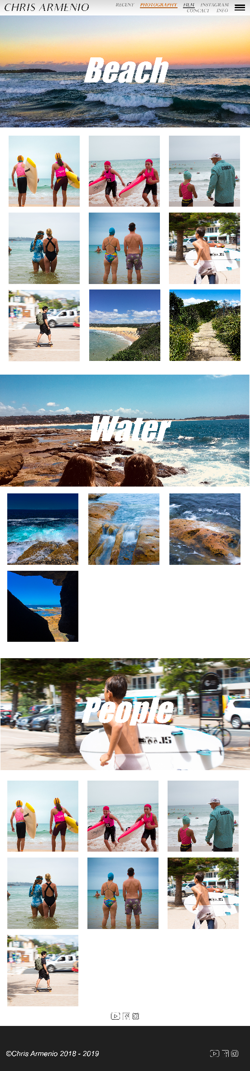

Each links to a different page

My name, (Chris Armenio), hyperlinks to the top of the page.

Hero showing the topic.

Images upload by JavaScript

Hyperlinks to Social Medias, YouTube, Facebook, and Instagram

Declaration of copyright

Toggle button, each hyperlink to a different

page which opens all the page tabs

My name, (Chris Armenio), hyperlinks to the top of the page.

Images in this category uploaded by JavaScript

Hero showing the topic

Hyperlinks to Social Medias, Youtube, Facebook, and Instagram

Declaration of copyright

